# Assignment Answer Sheet

|  |  |  |  |
| --- | --- | --- | --- |
| **Campus** | Pretoria | **Faculty** | IT |
| **Module Code** | ITECA | **Module Name** |  |
| **Student Name** | Arno Moller | | |
| **Student Number** | CC96ZRRS5 | | |

Declaration

“I declare that this assignment is my own original work except for source material explicitly acknowledged, and that the same or related material has not been previously, or is being simultaneously, submitted for this or any other course. I also acknowledge that I am aware of the Institution’s policy and regulations on honesty in academic work as set out in the Eduvos Conditions of Enrolment, and of the disciplinary guidelines applicable to breaches of such policy and regulations.”

*Start writing from here.*

**Question 2**

Figure 1 Top of Webpage

Figure 2 Zoomed out image.

***The next images are screenshots of the webpage when scrolling down.***

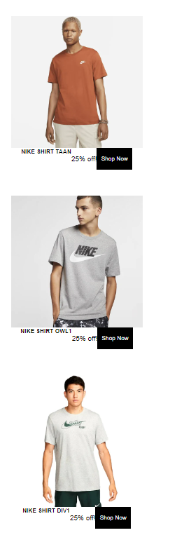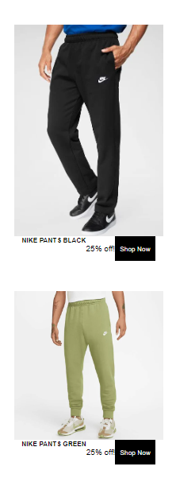

***HTML and CSS:***

<!DOCTYPE html>

<html lang="en">

<head>

<meta charset="UTF-8">

<meta name="viewport" content="width=device-width, initial-scale=1.0">

<link rel="stylesheet" href="styles.css">

<title>Black Friday</title>

</head>

<body>

<header>

<h1>Black Friday Sale</h1>

<p>Don't miss out on our amazing deals we have to OFFER!</p>

</header>

<section class="offers">

<h2>Our Offers</h2>

<div class="offer">

<img src="C:\Users\arnom\Desktop\Bsc IT 3\ITECA\Assignement\Question 2\Nike1" alt="Product 1">

<h3>NIKE AIR 1</h3>

<p>50% off!</p>

<button>Shop Now</button>

</div>

<div class="offer">

<img src="C:\Users\arnom\Desktop\Bsc IT 3\ITECA\Assignement\Question 2\niKE2.webp" alt="Product 2">

<h3>NIKE AIR 2</h3>

<p>40% off!</p>

<button>Shop Now</button>

</div>

<div class="offer">

<img src="C:\Users\arnom\Desktop\Bsc IT 3\ITECA\Assignement\Question 2\P5.webp" alt="Product 3">

<h3>NIKE AIR 3</h3>

<p>40% off!</p>

<button>Shop Now</button>

</div>

</section>

<section class= "Products">

<h4>New Products and Items</h4>

<div class="Product">

<img src="C:\Users\arnom\Desktop\Bsc IT 3\ITECA\Assignement\Question 2\Pr1.webp" alt="Product111">

<h4>NIKE BLUE</h4>

<p>50% off!</p>s

<button>Shop Now</button>

</div>

<div class="Product">

<img src="C:\Users\arnom\Desktop\Bsc IT 3\ITECA\Assignement\Question 2\P2.webp" alt="Product 12">

<h5>NIKE WHITE</h5>

<p>40% off!</p>

<button>Shop Now</button>

</div>

<div class="Product">

<img src="C:\Users\arnom\Desktop\Bsc IT 3\ITECA\Assignement\Question 2\P4.webp" alt="Product1 2">

<h5>NIKE STYLE</h5>

<p>25% off!</p>

<br><button>Shop Now</button>

</div>

<div class="Product">

<img src="C:\Users\arnom\Desktop\Bsc IT 3\ITECA\Assignement\Question 2\S1.webp" alt="Product1 2">

<h5>NIKE SHIRT LOGO</h5>

<p>25% off!</p>

<br><button>Shop Now</button>

</div>

<div class="Product">

<img src="C:\Users\arnom\Desktop\Bsc IT 3\ITECA\Assignement\Question 2\S2.webp" alt="Product1 2">

<h5>NIKE SHIRT PLAIN</h5>

<p>25% off!</p>

<br><button>Shop Now</button>

</div>

<div class="Product">

<img src="C:\Users\arnom\Desktop\Bsc IT 3\ITECA\Assignement\Question 2\S3.webp" alt="Product1 2">

<h5>NIKE SHIRT TAAN</h5>

<p>25% off!</p>

<br><button>Shop Now</button>

</div>

</div>

<div class="Product">

<img src="C:\Users\arnom\Desktop\Bsc IT 3\ITECA\Assignement\Question 2\S4.webp" alt="Product1 2">

<h5>NIKE SHIRT OWL1</h5>

<p>25% off!</p>

<br><button>Shop Now</button>

</div>

</div>

<div class="Product">

<img src="C:\Users\arnom\Desktop\Bsc IT 3\ITECA\Assignement\Question 2\S5.webp" alt="Product1 2">

<h5>NIKE SHIRT DIV1</h5>

<p>25% off!</p>

<br><button>Shop Now</button>

</div>

</div>

<div class="Product">

<img src="C:\Users\arnom\Desktop\Bsc IT 3\ITECA\Assignement\Question 2\I1.webp" alt="Product1 2">

<h5>NIKE PANTS BLACK</h5>

<p>25% off!</p>

<br><button>Shop Now</button>

</div>

</div>

<div class="Product">

<img src="C:\Users\arnom\Desktop\Bsc IT 3\ITECA\Assignement\Question 2\I2.webp" alt="Product1 2">

<h5>NIKE PANTS GREEN</h5>

<p>25% off!</p>

<br><button>Shop Now</button>

</div>

</section>

<section class="delivery">

<h6>Delivery Details</h6>

<p>Free shipping on orders over R500 during Black Friday!</p>

</section>

</body>

</html>

***CSS***

body {

font-family: Arial, sans-serif;

margin: 0;

padding: 0;

}

h1, h2, h3, h4, h5, h6, h7 {

margin: 0;

padding: 0;

}

button {

background-color: #000;

color: #fff;

border: none;

padding: 10px;

cursor: pointer;

}

/* Header */

header {

background-color: #000;

color: #fff;

padding: 20px;

text-align: center;

}

/* Offers */

.offers {

display: flex;

flex-wrap: wrap;

justify-content: center;

padding: 20px;

}

.offer {

width: 100%;

max-width: 300px;

margin: 20px;

text-align: center;

}

.offer img {

width: 100%;

height: auto;

}

/* Products */

.Product {

display: flex;

flex-wrap: wrap;

justify-content: center;

padding: 20px;

}

.Product {

width: 100%;

max-width: 300px;

margin: 20px;

text-align: center;

}

.Product img {

width: 100%;

height: auto;

}

/* Delivery */

.delivery {

background-color: #eee;

padding: 20px;

text-align: center;

}

@media (min-width: 768px) {

.offers {

flex-wrap: nowrap;

}

}

Figure 3 HTML AND CSS Coding

# Bibliography

Clifford Stein , Robert Drysdale, Kenneth Bogart. (2011). *Discrete Mathematics for computer scientists .* United states of America: Pearson Education.

Gaddis, T. (2013). *Starting out with Programming Logic & Design.* United states: Pearson Education.

Hagarty, R. (2002). *Discrete Mathematics for computing.* Malaysia: Pearson Education limited.

Kolman, B. (1997). *Introductou Linear Algebra with applications.* New Yersey: Prentice -Hall, Inc.

RichardJohnsonbaugh. (2009). *Discrete Mathematics.* United states of America: Pearson Education.

Laudon, K. and Traver, C. 2020. E-Commerce 2020-2021: Business. Technology and Society, Global Edition, 17th Edition. Pearson UK

Nixon, R. 2021. Learning PHP, MySQL & JavaScript: With jQuery, CSS & HTML5. 6th edition. O’Reilly Media, Inc.

Nixon, R. 2015. Learning PHP, MySQL & JavaScript: With jQuery, CSS & HTML5. 4th Edition. O’Reilly Media, Sebastopol.

Schneider, G.P. 2017. Electronic commerce. 12th Edition. Cengage Learning, Boston

Afuah, A. and Tucci, C.L. 2000. Internet business models and strategies. 2nd edition. Pretoria: University of Pretoria.

Andersson, E.A., Greenspun, P. and Grumet, A. 2006. Software engineering for Internet applications. Cambridge: MIT Press.

Campbell, B. and Darnell, R. 1997. Teach yourself dynamic HTML in a week. Indianapolis: SAMS.

Chaffey, D. 2002. E-business and e-commerce management: strategy implementation and practice. 3rd edition. England: Pearson Education.

Deitel, H.M.; Deitel, P.J. and Nieto, T.R. 2001. E-business and e-commerce: how to program. New Jersey: Prentice Hall.

Laudon, K.C. and Traver, C.G. 2013. E-commerce 2014. New York: Prentice Hall.

Turban, E., King, D.R. and Lang, J. 2009. Introduction to e-commerce. New Jersey: Prentice Hall.

Ullman, L. 2014. PHP and MySQL for dynamic websites: Visual QuickPro guide. Berkeley: Peachpit Press.

Welling, L and Thomson, L. 2017. PHP and MySQL Web Development. Addison-Wesley Professional.

Complete Full Stack Website Development PHP. 2021. [Online] Available at: <https://www.youtube.com/watch?embed=no&v=jrYUUKh_lKg>. [Accessed: 13 December 2022

HTML Forms and PHP. 2021. [Online] Available at: <https://www.youtube.com/watch?embed=no&v=2HVKizgcfjo>. [Accessed: 13 December 2022].